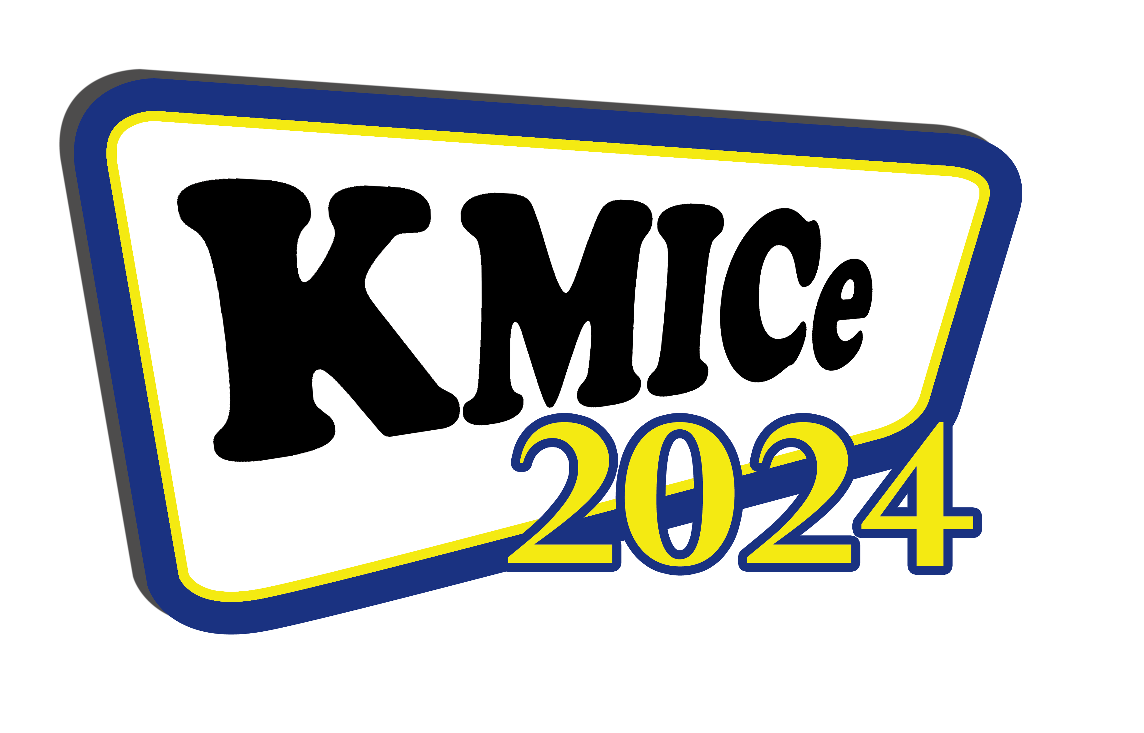
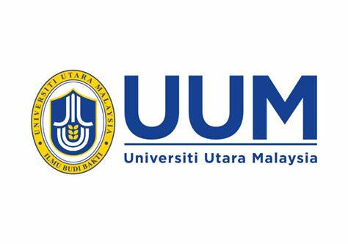

11th Knowledge Management International Conference (KMICe) 2024
2-3 October 2024, Putrajaya, Malaysia

COPYRIGHT TRANSFER AGREEMENT

(This Copyright Transfer Form is mandatory and has to be filled up and signed)

Title of Paper:
Author (s):
(list all authors)

I/We hereby declare that the material being presented by me/us is my/our original work, and does not include any material taken from other copyrighted sources. Whenever such material has been included, it has been clearly referred to and acknowledged at the appropriate places in the manuscript.

I/We also grant and assign exclusively to Universiti Utara Malaysia (hereafter referred to as “the Organizer”) all rights of whatsoever kind or nature now or hereafter protected by Copyright Laws of the Government of Malaysia. This assignment gives the Organizer the right to register copyright to the paper in its name as claimant and to publish the above-titled paper in any other printed or electronic medium.

I/We authorize the undersigned who has been corresponding with KMICe 2024 Conference authorities during the processing of paper to sign in favor of every one of us.

Name of Corresponding Author:

Address:

E-Mail Address:

Signature:

Date:

*please upload this copyright form through the system together with the Camera Ready and also submit it to us by email (kmice@uum.edu.my) by 22 September 2024

